Wetland Report:

Lettuce Lake Park

Jared Searle

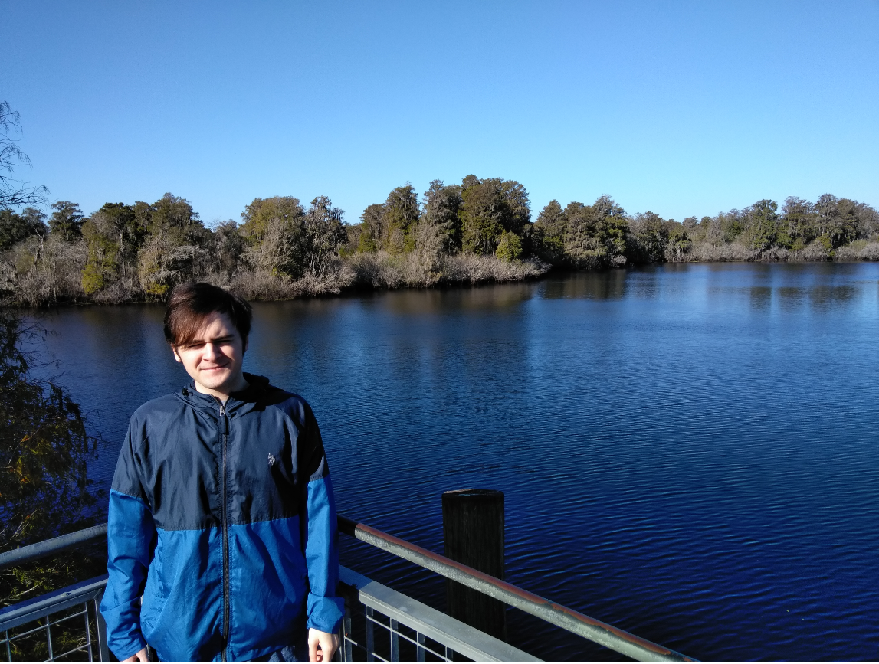

The Wetlands are perhaps one of Earth’s most unique and useful ecosystems. They fill many important environmental roles such as water filtration, erosion control and provide a habitat for a wide array of plants and animals . I will briefly cover each of these roles. Commonly referred to as “Earth’s Kidneys”, they play an important role in the purification of water. This process occurs via the flow of water through a wetland. Wetlands generally contain an extremely high concentration of vegetation, most of which possesses dense roots. As water flows through a wetland, it is gradually slowed. This slower movement allows sediments and other impurities in the water to settle, effectively cleaning the water. This is only one of their important roles. They also protect against the erosion of coastlines. This is done by their dense roots, which serve two main purposes. These roots hold soil in place, which can either divert water flow away from coastlines, or can serve as an effective ‘shock absorber’ against waves. They also serve as a habitat for thousands of species of animals and plants.

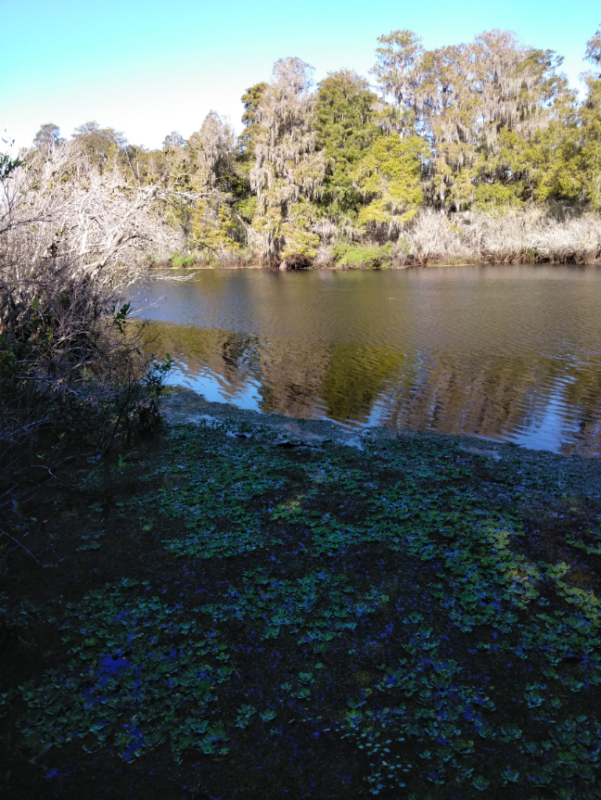

For my paper I decided to visit Lettuce Lake Park, a freshwater non-tidal alluvial swamp which lies in a natural floodplain of the Hillsborough River. It is located on East Fletcher Avenue, right outside the city limits of Hillsborough County in Tampa, Florida. I made my observations in the early afternoon on the second of November.

The State of Florida possesses an extremely humid and muggy climate, with moderate amounts of rainfall; the humidity generally sits at around seventy to eighty percent year-round. Geographically, Florida is a peninsula—a coastal landmass surrounded by water on three sides. It sits upon the North American Continental shelf. Due to its proximity to the ocean, the ground here is comprised primarily of Limestone. This naturally formed sedimentary rock contains an overabundance of calcium carbonate—a naturally occurring compound that serves as a pH neutralizer. When added to a soil, it either raises or lowers the pH (depending on the starting pH of the soil), making it more alkaline. This compound plays a significant role in determining the composition of the soil itself, and by extension, the types of plant and animals that will inhabit its ecosystem. Another key element that will influence the ecosystem is the aforementioned rainfall.

It is important to note the time of year I made my observations. During the later parts of the year, the water levels in a wetland drop; so much so that water marks are left behind on the trees. This was a very important factor when I evaluated the soil type. Lettuce Lake Park includes portions of the Hillsborough River and a boardwalk suspended over areas that were inundated with several feet of water. These sections are expected to be hydric as they were submerged year-round. As you move further inland, the water levels gradually decrease until you reach the high swamp. The water in the high swamp was only a few feet deep. This section contained dense colonies of water hyacinth, which suggests a soil that is both wet, oxygen rich and hydric. As we move into the section furthest from the river and approach the border of the wetland, though there is very little water, there is still an abundance of ‘organic litter’. This does not denote a hydric soil. Based off of what I have observed, the two sections that meet the criteria for hydric soils are the low and the high swamp. Both of these areas remained submerged for the entirety of the year and if I were to take a look at their soil profile, I would expect them to be hydric.

Hydrophytes, which literally translates to 'water-plant', are plants that have adapted to living in saturated environments. An important thing to note is the time of year during which I conducted my observations. Fall is the time of year when flowering plants ‘curl up’ and hibernate. This made it especially difficult to identify some of the plants, such as the water hyacinth and bulrush, as some of their more distinguishing features lie in their flowering parts. The hydrophytes that I was able to make out were the woody Mangroves, the towering Cypress, and the Live Oaks. For floating hydrophytes I was able to identify Water Lettuce and Duckweed. The only submergent hydrophyte I was able to make out was Hydrilla. Something else that was quite space was wildlife; I observed only a few Limpkins during my visit. A fairly common wading bird, these were spotted mainly in the high swamp and standing atop fallen tree branches.

Cypress Trees **(a)** are deciduous conifers, shedding their leaves in the fall. They typically stand between 15 and 21 meters tall. Some of their more distinctive features are their needlelike leaves and their pyramidal silhouettes. They possess a high water-requirement, being found in areas with heavy rainfall and by bodies of fresh-water. They feature adventitious roots which sprout from the bottom of their trunks. This adaptation helps provide support for the tree in wet conditions. Another tree that possesses this type of adaptation is the Oak Tree.

Oak trees **(b)** are perhaps one of the most iconic trees in the Tampa Bay Area. On average, they stand 21 meters tall however, some have reached more than 41 meters. They have a stout appearance, possessing branches that can measure more than two times their height. Oaks can survive in a variety of climates and naturally occurring ones can be found throughout the Northern Hemisphere, though they have been seen thriving in places as far South as Argentina and as far North as Quebec. There are over 17 species of Oak in the Tampa Bay area alone, and more than 600 species worldwide.

There are two main types of Oak, deciduous and Evergreen. Those in the Tampa Bay area are evergreen, which never completely shed their leaves. This type of tree is commonly referred to as ‘live oak’. These trees can tolerate saturated soils and can even grow in shallow bodies of water. They possess extremely dense buttresses, which are an adaptation of adventitious roots. These buttresses can easily cover an area several times larger than the crown of the tree.

Named for its resemblance to lettuce, the Water Lettuce **(c)** is a Non-Native perennial floating evergreen. Originally from South America, this invasive species is considered to be the world’s worst weed. These plants generally grow to be 20 inches in length and can cover an area of several square meters. However, like most floating hydrophytes, they possess extremely long and dense roots that lie beneath the surface.

These dense and long-reaching roots can block out sunlight and prevent dissolution of oxygen, causing the death of fish and other plant life. Another floating hydrophyte is Duckweed.

Duckweed **(d)** is a small flowering aquatic plant that finds its home in freshwater wetlands and sedentary bodies of water. Unlike most plants, Duckweed does not possess differentiated plant structures, such as stems or leaves. Instead, the majority of the plant consists of undifferentiated structures called thallus. These dense structures are often composed of aerenchyma, which is what allows the plant to float. Unlike most plants, Duckweed does not possess differentiated plant structures, such as stems or leaves. Instead, the majority of the plant consists of undifferentiated structures called thallus. These dense structures are often composed of aerenchyma, which is what allows the plant to float. The last species I documented was Hydrilla.

Hydrilla **(e)** is an invasive aquatic species—and is classified as an ‘aquatic weed’. It is identified by its lime-green stems and dark green whorls, which average 20 millimeters in length. The plant itself can reach 1 to 2 meters in length.

Due to the its variety of hydrophytic plants as well as signs of hydric soil, I believe that Lettuce Lake Park meets the criteria for wetland identification. Below are some images documenting the species mentioned in my report:

1. *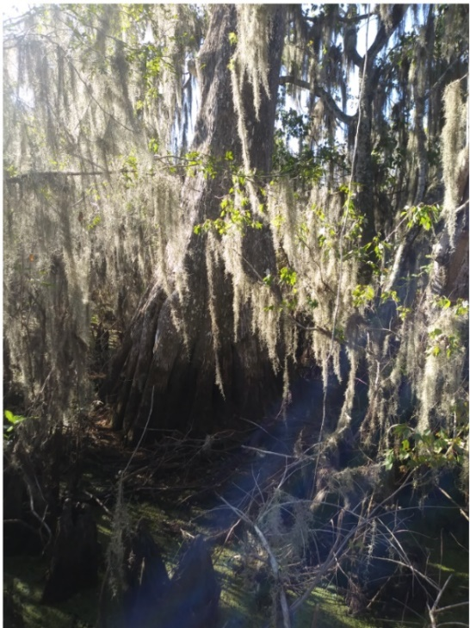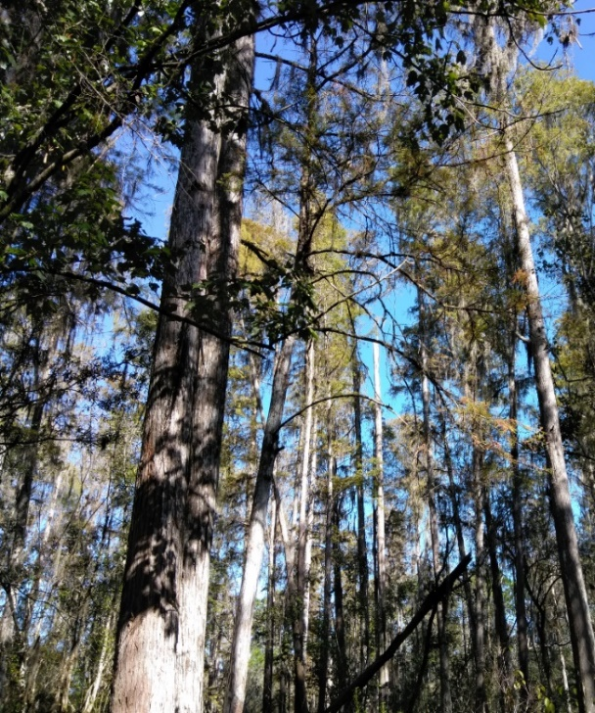Cypress Tree – (Cupressus)*  (b)*Oak Tree – (Quercus)*

(c)*Water Lettuce—(Pistia stratiotes)*  (d) *Duckweed--(Lemna minor)*

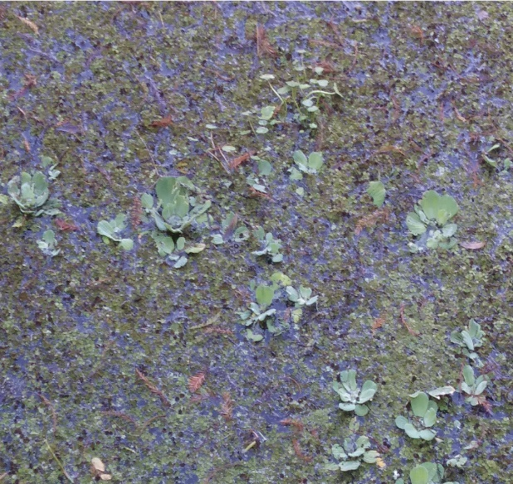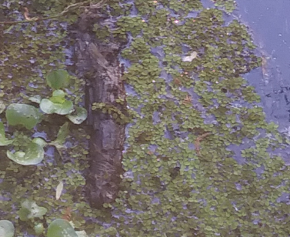

( e ) -*Hydrilla (*Hydrilla *verticillate)*

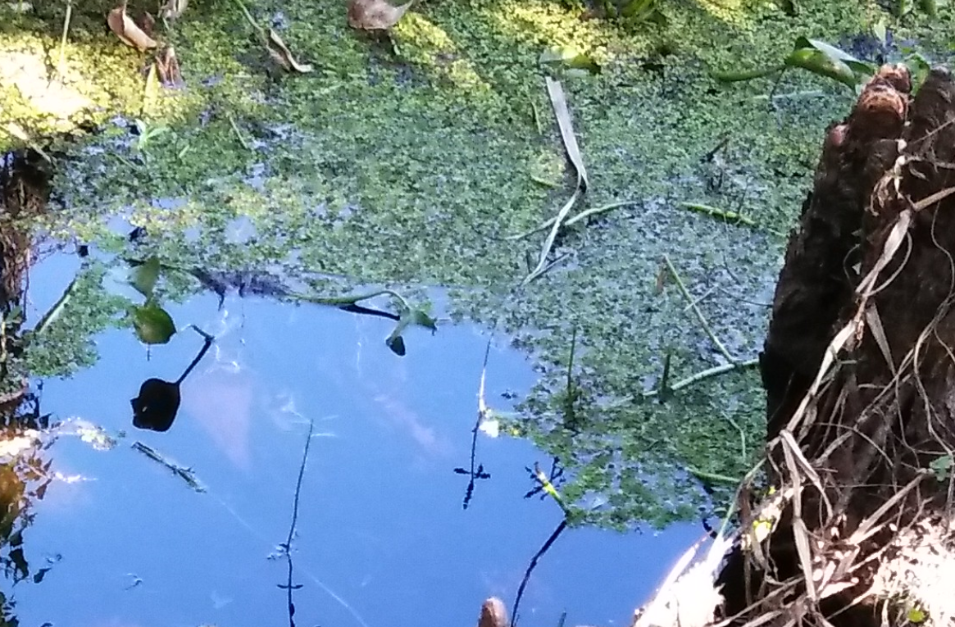

Despite their ban on littering, I noticed several pieces of trash thrown in the water. There were several Park pamphlets and even an occasional plastic bottle. If anything were to be changed about the park, I would enforce more stringent policies regarding litter, as trash pollutes the land and can be hazardous and potentially fatal to wildlife. The park has been referred to in its website as a “glimpse back in time”. Despite this, the park has remained in its current condition and has gone largely unchanged since its opening in 1982.

As is common with most wetlands, the one at Lettuce Lake Park serves as a means of erosion control and acts as a natural occurring barrier, protecting the land directly behind the riverbank. The Water Hyacinths and other hydrophytes possessing dense roots serve a passive role in purifying the waters within the wetland. Due to its proximity to the Hillsborough river, I believe that if proper care was not given and proper measures were not taken, that the collateral damage would prove immense. The ground in Florida is highly susceptible to the formation of sinkholes and erosion contributes greatly to their opening. By maintaining the health of Lettuce Lake park and other wetlands like it, we can limit the damage done not only to ourselves but to the world in which we inhabit.

Sources:

-Class Lectures & Notes

-Mitsch, William J., and James G. Gosselink. *Wetlands*, John Wiley & Sons, Incorporated, 2010. *ProQuest Ebook Central*, <http://ebookcentral.proquest.com/lib/usf/detail.action?docID=819004>.

- Plaques at Lettuce Lake Park